**16-BIT DIVISION**  
  
  
**EXP NO: 8**  
  
**AIM:**To write an assembly language program to  
implement 16-bit divided by 8-bit using 8085 processor.  
  
**ALGORITHM:**  
  
1)      Read  
dividend (16 bit)  
  
2)      Read  
divisor

3)      count  
<- 8  
  
  
4)      Left  
shift dividend  
  
  
5)      Subtract  
divisor from upper 8-bits of dividend  
  
  
6)      If  
CS = 1 go to 9  
  
  
7)      Restore  
dividend  
  
  
8)      Increment  
lower 8-bits of dividend  
  
  
9)      count  
<- count - 1  
  
  
10)  If  
count = 0 go to 5  
  
  
11)  Store  
upper 8-bit dividend as remainder and lower 8-bit as quotient  
  
  
12)  Stop  
  
  
**PROGRAM:**  
  
  
LDA 8501  
  
  
MOV B,A  
  
  
LDA 8500  
  
  
MVI C,00  
  
  
LOOP:CMP B  
  
  
JC LOOP1  
  
  
SUB B  
  
  
INR C  
  
  
JMP LOOP  
  
  
STA 8503  
  
  
DCR C  
  
  
MOV A,C  
  
  
LOOP1: STA 8502  
  
  
RST 1  
  
  
 

**INPUT:**

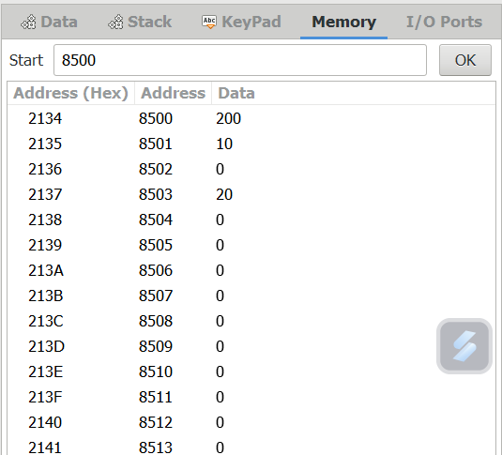  
  
  
  
  
  
**OUTPUT:**

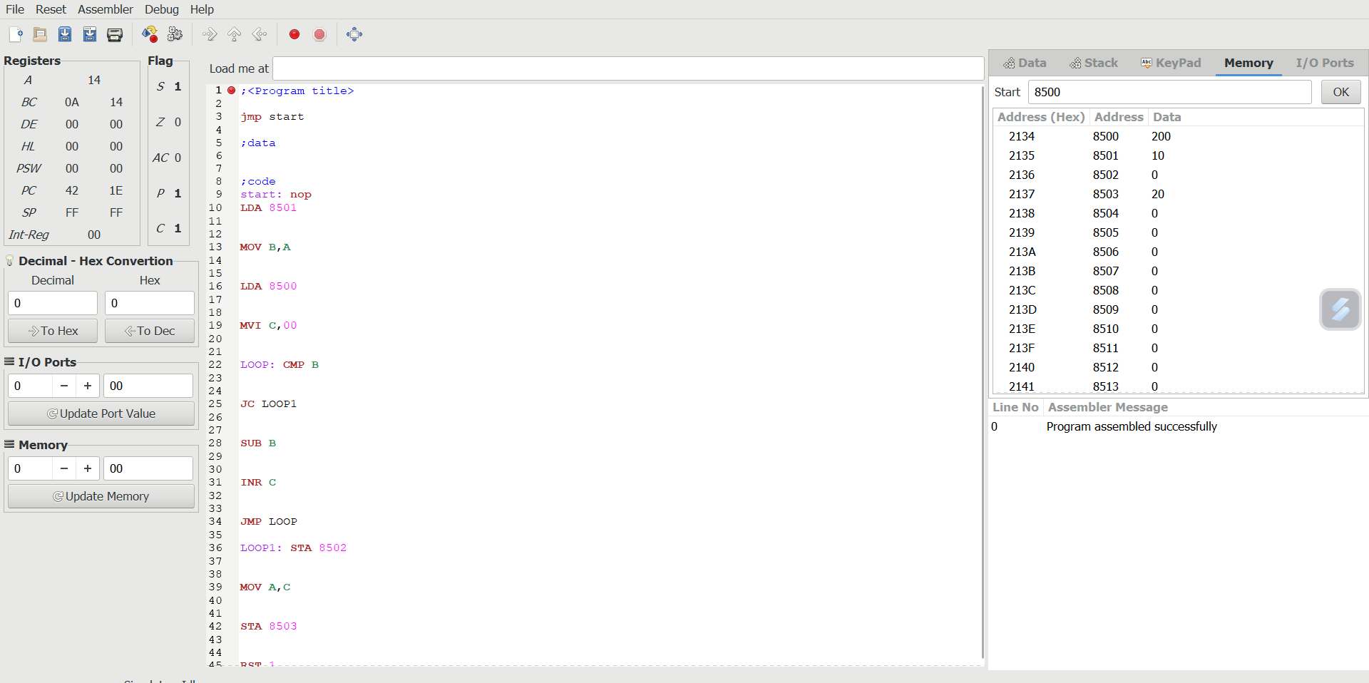  
  
  
**RESULT:**Thus the program was executed successfully using 8085  
processor simulator.